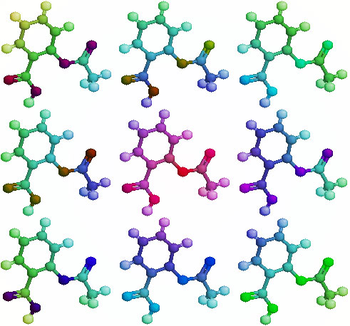
ORGANIC CHEMISTRY
TEXTBOOK: CHAPTER 20 Pages 633-681

HOMEWORK DUE: _______________

Free Response: _______________
Multiple Choice: _______________

ORGANIC CHEMISTRY STUDENT OUTLINE AND STUDY GUIDE

I. HYDROCARBONS
- Characteristics of organic compounds include generally nonpolar molecules, low melting point due to weak van der waals, generally insoluble in water
- Hydrocarbons - a class of organic compounds containing hydrogen and carbon
- Homologous series - groups of hydrocarbons classified by structure and properties (for naming refer to Table P and Q)
- Aliphatic hydrocarbons
  - Alkane: C_{n}H_{2n+2}
  - Alkene: C_{n}H_{2n}
  - Alkyne: C_{n}H_{2n-2}
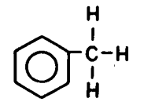
Aromatic hydrocarbons C_{n}H_{2n-6} (contain a benzene ring)
1. Benzene C₆H₆ 2. Toluene C₇H₈
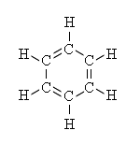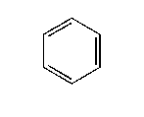
- Isomers - compounds with the same molecular formula but different structural formula. (increasing the number of carbons in a chain, increases the number of possible isomers). Example of the 2 isomers of butane…
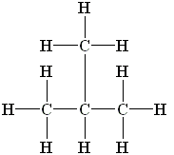
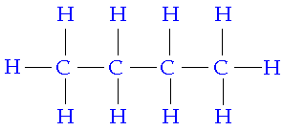

n-Butane C₄H₁₀ Isobutane or 2-methyl propane C₄H₁₀

- IUPAC rules states that names are a derivative of the longest continuous chain; carbon atoms are numbered consecutively from either side to produce the smallest number of "attached" groups. Attached side chains are named with a -yl ending.

II. ORGANIC FUNCTIONAL GROUPS (TABLE R)
Functional group - group of atoms, other that hydrogen, attached to the carbon chain (R represents a chain of carbons with hydrogen). Diagrams show examples of each type

1. Alcohols ROH
Types of alcohols are based on number and location of hydroxyl group (OH).
A. Monohydroxy alcohols (1 -OH group)
- Primary - the carbon with the -OH is attached to one other carbon
- Secondary - the carbon with the -OH is attached to two other carbons
- Tertiary - the carbon with the -OH is attached to three other carbons
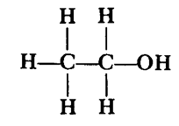
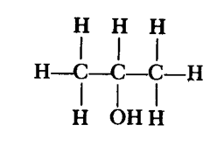
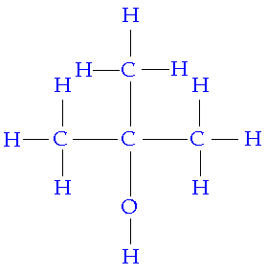

Ethanol (primary) 2-propanol (secondary) 2-methyl-2-propanol (tertiary)

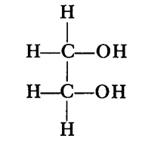
B. Dihydroxy alcohols (2 -OH groups)
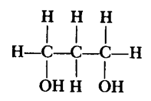

1,3-dihydroxy propanol 1,2-dihydroxy ethanol
(1,3-propandiol) (1,2-ethandiol)
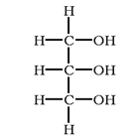
C. Trihydroxy alcohols (3 -OH groups)

Glycerol 1,2,3-trihydroxy propanol
(1,2,3-propantriol)

2. Organic Acids RCOOH 3. Aldehydes RCHO
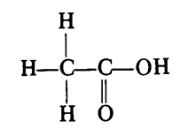
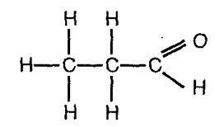

Ethanoic acid CH₃COOH Propanal CH₃CH₂CHO

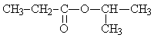
4. Ketones RCOR 5. Esters RCOOR
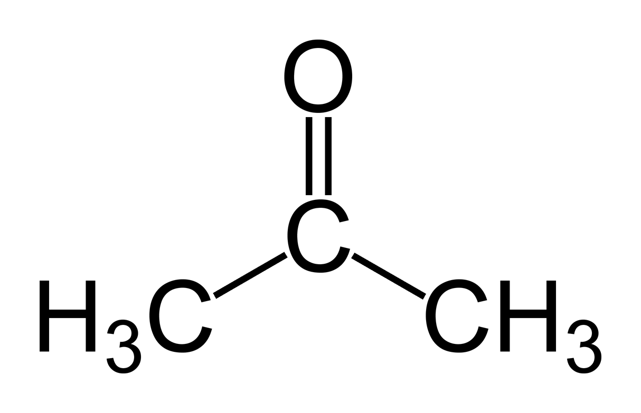

Propanone CH₃COCH₃ ethyl propanoate CH₃CH₂COOCH₂CH₃

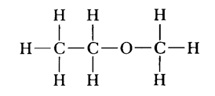
6. Ethers ROR 7. Amines RNH₂
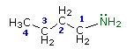

Ethyl methyl ether CH₃CH₂OCH₃ butylamine CH₃CH₂CH₂CH₂NH₂

III. ORGANIC REACTIONS (no chart; these must be memorized)

A. esterification: formation of an ester
organic acid + alcohol → ester + water
example: ethanoic acid + 1-propanol → propyl ethanoate + water

B. fermentation: breaking down of sugar without oxygen; products are ethanol and carbon dioxide; enzymes provided by yeast or bacteria
example: glucose → ethanol + carbon dioxide

C. oxidation: combustion or burning of hydrocarbons with oxygen to form carbon dioxide and water; supplies our society with energy
hydrocarbon + oxygen → water + carbon dioxide
example: ethane + oxygen → water + carbon dioxide

D. substitution: replacing one atom with another; saturated hydrocarbons remain saturated; includes hydrogenation or halogenation
example: ethane + bromine → bromoethane + hydrogen bromide

E. addition: adding two atoms to either side of a double bond; unsaturated hydrocarbons are made saturated
example: ethene + bromine → 1,2 dibromoethane

F. saponification: hydrolysis (breaking apart) of an ester in the presence of a base. The ester used is a lipid (fat).
Lipid(containing 3 esters) + base → 3 soap (sodium stearate) + glycerol

G. polymerization: formation of long chain organic compounds that are made of smaller repeating units bonded together.
Example: ethene → polyethylene
Best known manmade polymers: nylon, rayon, polyethylene
Natural polymers: proteins, starch, cellulose

ORGANIC CHEMISTRY VOCABULARY

Homologous series functional group organic reactions
Organic compounds alcohols substitution
Hydrocarbons monohydroxy alcohol addition
Aliphatic primary alcohol halogenation
Alkane secondary alcohol hydrogenation
Alkene tertiary alcohol fermentation
Alkyne dihydroxy alcohol esterification
Aromatic trihydroxy alcohol saponification
Benzene organic acids polymerization
Isomers aldehydes condensation polymerization
Molecular formula ketones addition polymerization
Structural formula ester natural polymers
IUPAC names ether synthetic polymers
Prefixes Suffixes

ORGANIC CHEMISTRY HOMEWORK PACKET

Chapter 22 Basics of Hydrocarbons

Textbook page771

11.

12. a. _______________________ b._________________________

Textbook page 773

16. _____________________________________________________________________________________

_________________________________________________________________________________________

Textbook page 790-793

45. b.____________________________

46. b._________________________

47. a.______________________________________________________________________________

b.____________________________________________________________________________

61 a.
61 d.

65.____________________________________________________________________________________

Textbook page 790-793

69a._______ 69e.________

79. _____________________________________________________________________________________
_________________________________________________________________________________________

Textbook page 795

1.____________ 9.___________ 11.___________ 12.____________ 13.___________ 1 4.____________

General Organic Chemistry
1. What is the structural difference between an aliphatic and aromatic hydrocarbon?

2. What is a homologous series of hydrocarbons?

3. What makes carbon able to form so many different compounds?

4. What are structural isomers?

5. What is the smallest alkane that has a structural isomer? __________

6. Draw the structural formulas and state the names for the three isomers of pentane. Complete the chart.
 | STRUCTURAL FORMULA | NAME
ISOMER 1

ISOMER 2

ISOMER 3

Chapter 23 Functional Groups

Textbook page 802

3. _____________________________________________________________________________________

4a. _____________________________________________________________________________________

4b. _____________________________________________________________________________________

4c. _____________________________________________________________________________________

4d. _____________________________________________________________________________________

4e. _____________________________________________________________________________________

4f. _____________________________________________________________________________________

Textbook page 811

10. _____________________________________________________________________________________

14b.
14d.

Textbook page 820

21a.__________________________ 21b._________________________ 21c.__________________________

22a.__________________________ 22b._________________________ 22c.__________________________

Textbook page 827

24. _____________________________________________________________________________________

25. _____________________________________________________________________________________

Textbook page 830-831

37. c._________________________

52 a.
52 b .

53 a.________________________________________ b.___________________________________________

c.________________________________________ d.____________________________________________

C. ORGANIC REACTIONS

1. Write the chemical formulas in place of the names in the equations below.

A. esterification: ethanoic acid + 1-propanol → propyl ethanoate + water

B. fermentation: glucose → ethanol + carbon dioxide

C. oxidation: ethane + oxygen → water + carbon dioxide

D. substitution: : ethane + bromine → bromoethane + hydrogen bromide

E. addition: ethene + bromine → 1,2 dibromoethane

2. Complete each of the following chemical equations.

A. C₆H₁₄ + O₂ →

B. C₃H₆ + Cl₂ →

C. C₃H₈ + Cl₂ →

3. Polyethylene is a tough, flexible plastic used to make bottles, garbage bags and many other household items. Teflon is an inert, tough and nonflammable material used for electrical insulation and nonstick coatings for cooking utensils. Draw the structural formulas and state the names for the monomers that will become these useful polymers. (Hint: Find the answers in your textbook & notes)

Polyethylene Teflon

